QUESTION BANK
CHAPTER-4
CHEMICAL BONDING
ONE MARK QUESTIONS
Q.1. What is the total number of sigma and pi bonds in the following molecules?
(a) C2H2 (b) C2H4
Ans- there are three sigma and two pi-bonds in C2H2. There are five sigma bonds and one pi-bond in C2H4.
Q.2. Write the significance of a plus and a minus sign shown in representing the orbitals.
Ans- Molecular orbitals are represented by wave functions. A plus sign in an orbital indicates a positive wave function while a minus sign in an orbital represents a negative wave function.
Q.3. How do you express the bond strength in terms of bond order?
Ans- Bond strength represents the extent of bonding between two atoms forming a molecule. The larger the bond energy, the stronger is the bond and the greater is the bond order.
Q.4. Define the bond length. Ans- Bond length is defined as the equilibrium distance between the nuclei of two bonded atoms in a molecule
Q.5. Arrange the bonds in order of increasing ionic character in the molecules: LiF, K2O, N2, SO2 and ClF3. Ans- N2 < SO2 < ClF3 < K2O < LiF. Q.7. The skeletal structure of CH3COOH as shown below is correct, but some of the bonds are shown incorrectly. Write the correct Lewis structure for acetic acid.
Q.6. Define octet rule.
Ans- The elements tend to adjust the arrangement of their electrons in such a way that they (except H and He) achieve eight electrons in their outermost shell. This is called octet rule.
Q.7. Define lattice enthalpy.
Ans- The energy required when one mole of an ionic compound in crystalline form is split into the constituent ions is called lattice enthalpy.
Q.8. Which is type of bond formed when the atoms have zero difference in electronegativity?
Ans- Covalent bond.
TWO MARKS QUESTIONS
Q.1. Define hydrogen bond. Is it weaker or stronger than the van der Waals forces?
Ans- A hydrogen bond is defined as an attractive force acting between the hydrogen attached
to an electronegative atom of one molecule and an electronegative atom of a different
molecule (may be of the same kind). There are two types of H-bonds:
- Intermolecular H-bond e.g., HF, H2O etc. (ii) Intramolecular H-bond e.g., o-nitrophenol
Q.3. Although geometries of NH3 and H2O molecules are distorted tetrahedral, bond angle in water is less than that of ammonia. Discuss. Ans- The molecular geometry of NH3 and H2O can be shown as:

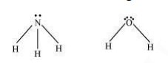
The central atom (N) in NH3 has one lone pair and there are three bond pairs. In H2O, there are two lone pairs and two bond pairs. The two lone pairs present in the oxygen atom of H2O molecule repels the two bond pairs. This repulsion is stronger than the repulsion between the lone pair and the three bond pairs on the nitrogen atom. Since the repulsions on the bond pairs in H2O molecule are greater than that in NH3, the bond angle in water is less than that of ammonia. Q.4. Explain the important aspects of resonance with reference to the ion.
Ans- According to experimental findings, all carbon to oxygen bonds in are equivalent. Hence, it is inadequate to represent ion by a single Lewis structure having two single bonds and one double bond. Therefore, carbonate ion is described as a resonance hybrid of the following structures:
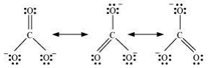
Q.5. H3PO3 can be represented by structures 1 and 2 shown below. Can these two structures be taken as the canonical forms of the resonance hybrid representing H3PO3? If not, give reasons for the same.
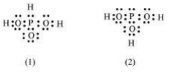
Ans- The given structures cannot be taken as the canonical forms of the resonance hybrid of H3PO3 because the positions of the atoms have changed.
Q.6. Use Lewis symbols to show electron transfer between the following atoms to form cations and anions: (a) Ca and O (c) Al and N. Ans(a) Ca and O: The electronic configurations of Ca and O are as follows: Ca: 2, 8, 8, 2 O: 2, 6 Oxygen requires two electrons more to complete its octet, whereas calcium has two electrons more than the nearest noble gas i.e., Argon. Hence, the electron transfer takes place as:

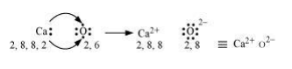
(b) Al and N:
The electronic configurations of Al and N are as follows: Al: 2, 8, 3 N: 2, 5 Nitrogen is three electrons short of the nearest noble gas (Neon), whereas aluminium has three electrons more than Neon. Hence, the electron transference can be shown as:
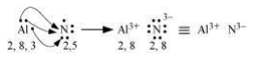
Q.7. Although both CO2 and H2O are triatomic molecules, the shape of H2O molecule is bent while that of CO2 is linear. Explain this on the basis of dipole moment.
Ans- According to experimental results, the dipole moment of carbon dioxide is zero. This is possible only if the molecule is linear so that the dipole moments of C– O bonds are equal and opposite to nullify each other.
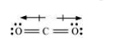
Resultant μ = 0 D H2O, on the other hand, has a dipole moment value of 1.84 D (though it is a triatomic molecule as CO2). The value of the dipole moment suggests that the structure of H2O molecule is bent where the dipole moment of O–H bonds are unequal.
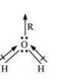
Q.8. Write the significance/applications of dipole moment.
Ans- Dipole moment is the measure of the polarity of a bond. It is used to differentiate between polar and non-polar bonds since all non-polar molecules (e.g. H2, O2) have zero dipole moments. It is also helpful in calculating the percentage ionic character of a molecule.
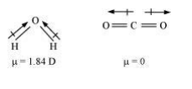
Q.9. Use molecular orbital theory to explain why the Be2 molecule does not exist. Ans- The electronic configuration of Beryllium is . The molecular orbital electronic configuration for Be2 molecule can be written as:
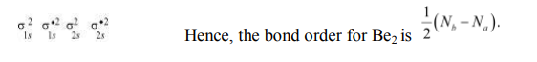
Where, Nb = Number of electrons in bonding orbitals Na = Number of electrons in anti-bonding orbitals Bond order of Be₂ 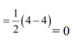 = 0 A negative or zero bond order means that the molecule is unstable. Hence, Be2 molecule does not exist.
Q.10. Distinguish between a sigma and a pi bond.
Ans- The following are the differences between sigma and pi-bonds:
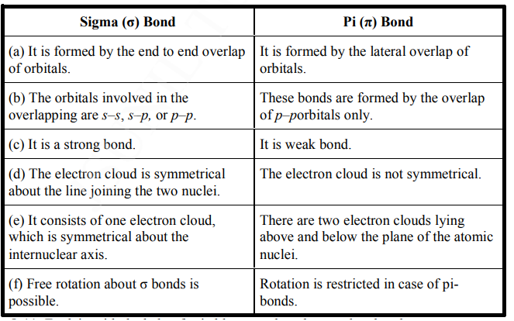
Q.11. Explain with the help of suitable example polar covalent bond.
Ans- When two dissimilar atoms having different electronegativities combine to form a covalent bond, the bond pair of electrons is not shared equally. The bond pair shifts towards the nucleus of the atom having greater electronegativity. As a result, electron distribution gets distorted and the electron cloud is displaced towards the electronegative atom. As a result, the electronegative atom becomes slightly negatively charged while the other atom becomes slightly positively charged. Thus, opposite poles are developed in the molecule and this type of a bond is called a polar covalent bond. HCl, for example, contains a polar covalent bond. Chlorine atom is more electronegative than hydrogen atom. Hence, the bond pair lies towards chlorine and therefore, it acquires a partial negative charge.
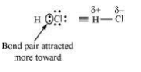
THREE MARKS QUESTIONS
Q.1. Write Lewis dot symbols for atoms of the following elements:
Mg, Na, B, O, N, Br. Ans- Mg: Na :
Q.3. Draw diagrams showing the formation of a double bond and a triple bond between carbon atoms in C2H4 and C2H2 molecules.
Ans- C2H4 :The electronic configuration of C-atom in the excited state is:
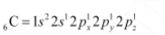
In the formation of an ethane molecule (C2H4), one sp 2 hybrid orbital of carbon overlaps a sp 2 hybridized orbital of another carbon atom, thereby forming a C-C sigma bond. The remaining two sp 2 orbitals of each carbon atom form a sp 2 -s sigma bond with two hydrogen atoms. The unhybridized orbital of one carbon atom undergoes sidewise overlap with the orbital of a similar kind present on another carbon atom to form a weak π-bond.
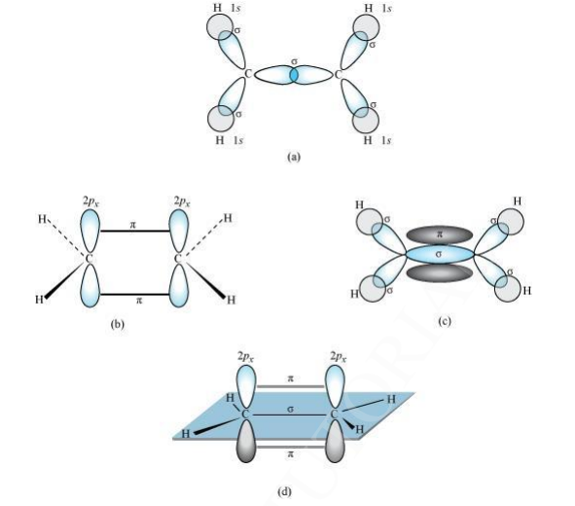
C2H2 : In the formation of C2H2 molecule, each C–atom is sp hybridized with two 2porbitals in an unhybridized state. One sp orbital of each carbon atom overlaps with the other along the internuclear axis forming a C–C sigma bond. The second sp orbital of each C–atom overlaps a half-filled 1s-orbital to form a σ bond. The two unhybridized 2p-orbitals of the first carbon undergo sidewise overlap with the 2p orbital of another carbon atom, thereby forming two pi (π) bonds between carbon atoms. Hence, the triple bond between two carbon atoms is made up of one sigma and two π-bonds.
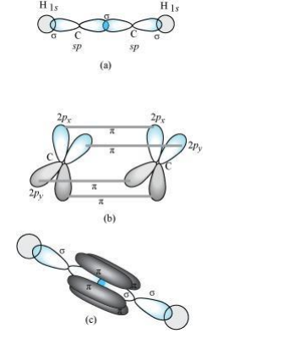
Q.4. Explain the formation of H2 molecule on the basis of valence bond theory. Ans- Let us assume that two hydrogen atoms (A and B) with nuclei (NA and NB) and electrons (eA and eB) are taken to undergo a reaction to form a hydrogen molecule. When A and B are at a large distance, there is no interaction between them. As they begin to approach each other, the attractive and repulsive forces start operating. Attractive force arises between: (a) Nucleus of one atom and its own electron i.e., NA – eA and NB – eB. (b) Nucleus of one atom and electron of another atom i.e., NA – eB and NB – eA. Repulsive force arises between: (a) Electrons of two atoms i.e., eA – eB. (b) Nuclei of two atoms i.e., NA – NB. The force of attraction brings the two atoms together, whereas the force of repulsion tends to push them apart.
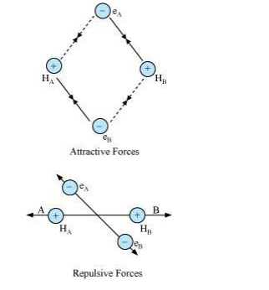
The magnitude of the attractive forces is more than that of the repulsive forces. Hence, the two atoms approach each other. As a result, the potential energy decreases. Finally, a state is reached when the attractive forces balance the repulsive forces and the system acquires minimum energy. This leads to the formation of a dihydrogen molecule.
Q.5. Write the important conditions required for the linear combination of atomic orbitals to form molecular orbitals.
Ans- The given conditions should be satisfied by atomic orbitals to form molecular orbitals:
(a) The combining atomic orbitals must have the same or nearly the same energy. This means that in a homonuclear molecule, the 1s-atomic orbital of an atom can combine with the 1s-atomic orbital of another atom, and not with the 2s-orbital.
(b) The combining atomic orbitals must have proper orientations to ensure that the overlap is maximum. (c) The extent of overlapping should be large.
Q.6. Describe the hybridisation in case of PCl5. Why are the axial bonds longer as compared to equatorial bonds?
Ans- The ground state and excited state outer electronic configurations of phosphorus (Z = 15) are: Ground state:
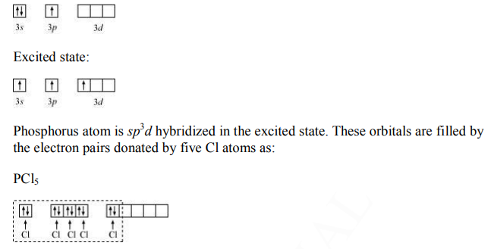

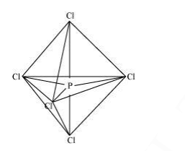
The five sp 3 d hybrid orbitals are directed towards the five corners of the trigonal bipyramidals.
Hence, the geometry of PCl5 can be represented as: There are five P–Cl sigma bonds in PCl5. Three P–Cl bonds lie in one plane and make an angle of 120° with each other. These bonds are called equatorial bonds. The remaining two P–Cl bonds lie above and below the equatorial plane and make an angle of 90° with the plane. These bonds are called axial bonds. As the axial bond pairs suffer more repulsion from the equatorial bond pairs, axial bonds are slightly longer than equatorial bonds.
Q.7. What is meant by the term bond order? Calculate the bond order of: N2, 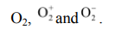
Ans- Bond order is defined as one half of the difference between the number of electrons present in the bonding and anti-bonding orbitals of a molecule.
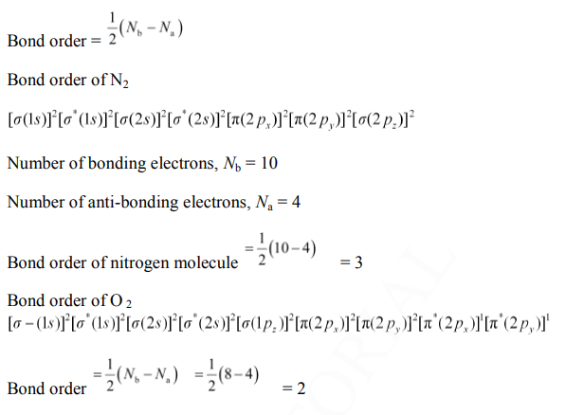
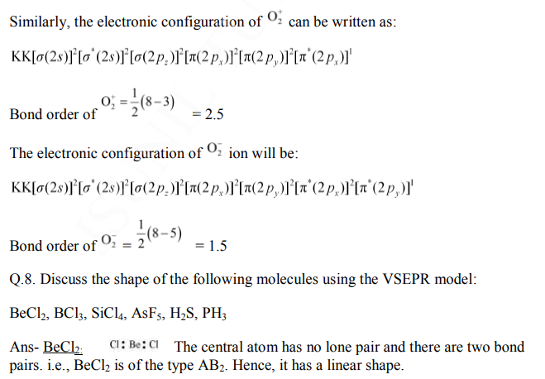
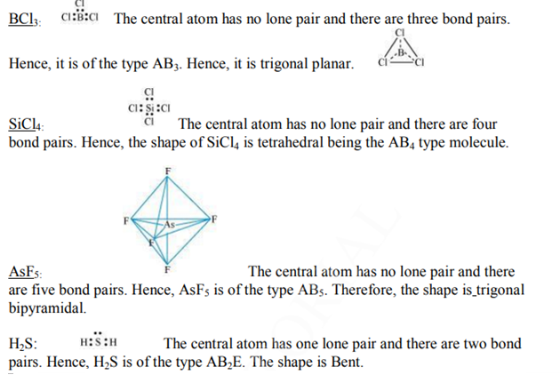
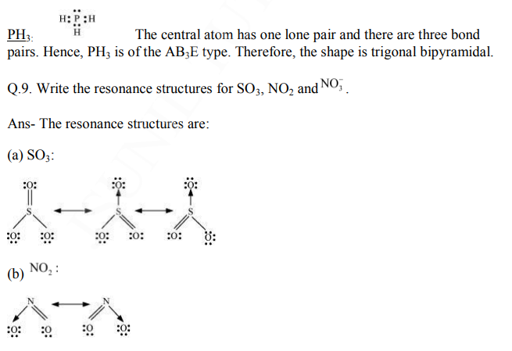
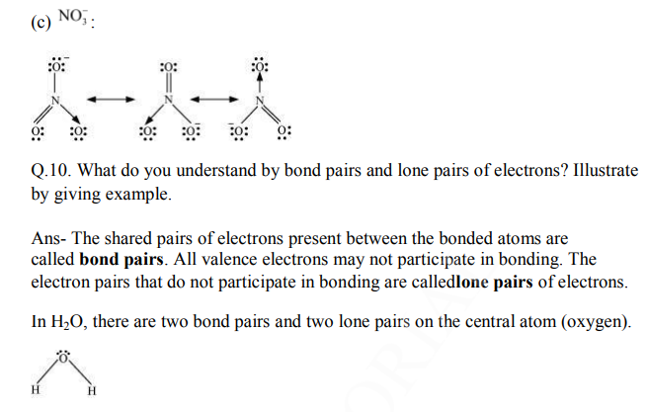

FIVE MARKS QUESTIONS
Q.1. Define octet rule. Write its significance and limitations.
Ans-- The octet rule or the electronic theory of chemical bonding was developed by Kossel and Lewis. According to this rule, atoms can combine either by transfer of valence electrons from one atom to another or by sharing their valence electrons in order to attain the nearest noble gas configuration by having an octet in their valence shell.
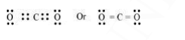
The octet rule successfully explained the formation of chemical bonds depending upon the nature of the element. Limitations of the octet theory: The following are the limitations of the octet rule: (a) The rule failed to predict the shape and relative stability of molecules. (b) It is based upon the inert nature of noble gases. However, some noble gases like xenon and krypton form compounds such as XeF2, KrF2 etc.
